Group Activity 7: CS 3060

Layne Woodruff, Caeli Empeck, Vanessa Burback
Points: 10

Task 1: (3 points) Consider the following Haskell function.

myFunc :: [Int] -> Int
myFunc [] = 1
myFunc (h:t) = 2 * h * (myFunc t)
main = print(myFunc [3,1,2])

Guess the output if you call ‘main’. Why so? Write your explanation in a few lines.
- We didn’t have a good guess, we just knew it was recursive so it’d be bigger than 6 with it multiplied.

Then, run the above code and verify whether your guess is correct. Paste a related screenshot below.
48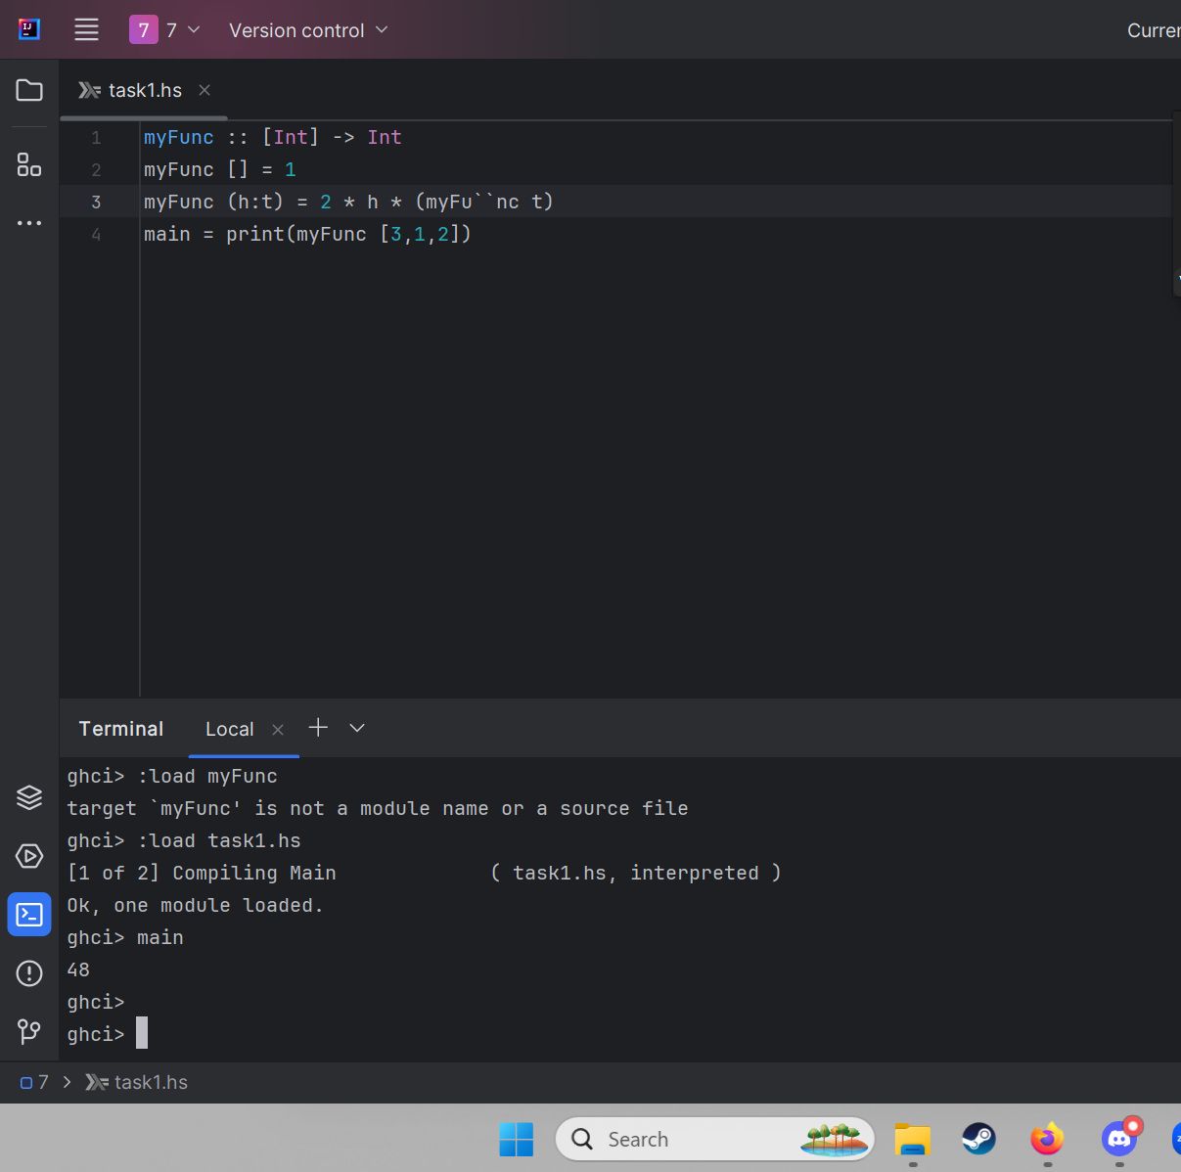

Task 2: (4 points) Write a Haskell function foo which takes a list of characters (Char) and returns the number of characters present in the list. If the list is empty foo returns zero.

foo :: [Char] -> Int
foo [] = 0
foo (_:t) = 1 + foo t
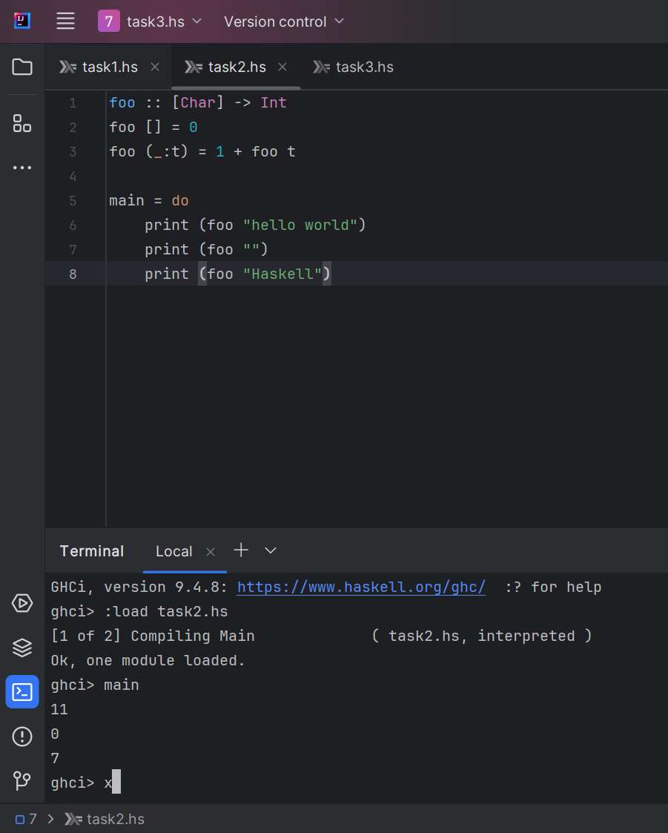

Task 3: (3 points) Run the following snippet of code, which uses the list comprehension technique to build a list.
players = ["x","y", "z"]
matches = [(m, n) | m <- players, n <- players, m < n]

Add one line of code to print the content of list matches. 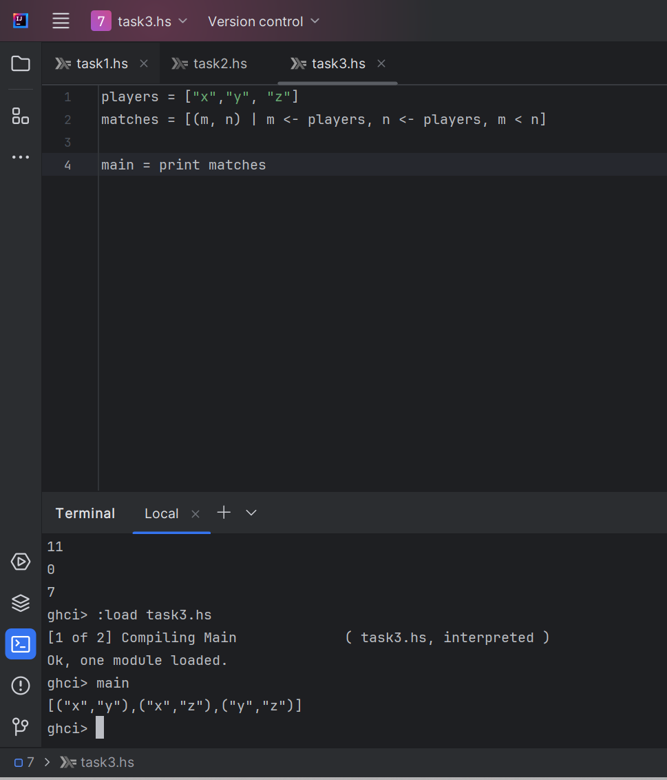
main = print matchesNow write a new piece of code to generate all permutations of letters a, b, and c. 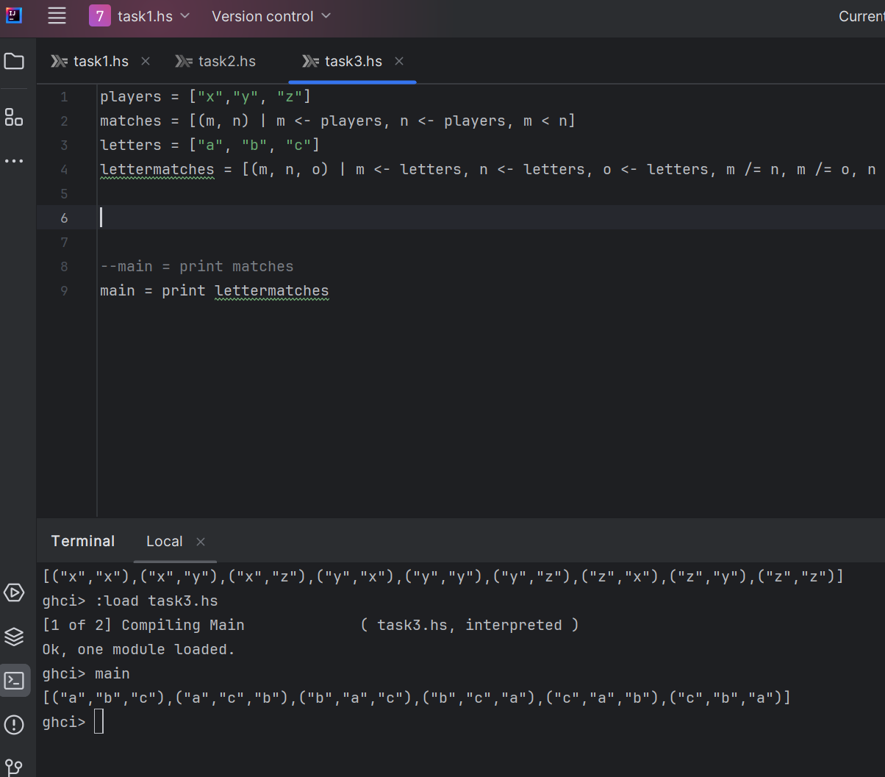

Submission: Submit one copy (per group) on Canvas.

